**FUNCTIONAL AND TECHNICAL COMBINED DOCUMENTATION**

**Page (25): WatchList--Equity (Front End Url:** http://localhost:8100/page25/Page25)

**Functional Picture:**

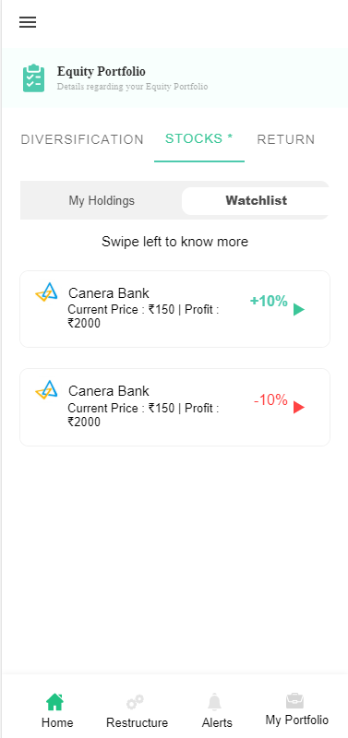

**In this Page, the user is going to see the list of stocks that the user has in his portfolio.**

**Technical Explanation (Front End and Back End):**

**In Page31.tsx, we are calling following 1 API:**

1. WatchListAPI: see backend python file. In this we are doing GET requests.

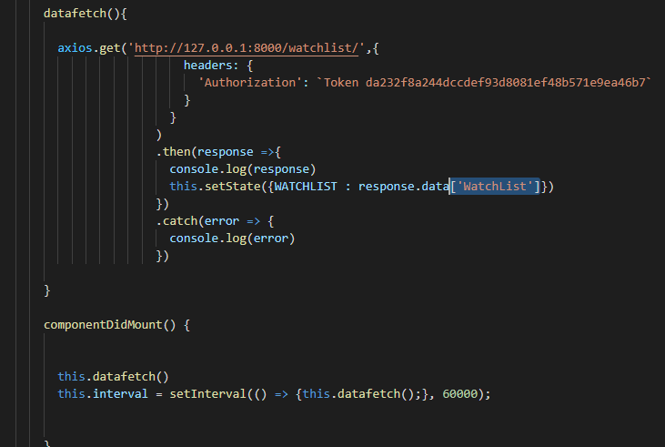

**As you can see, we are calling the** WatchListAPI

**using this url:** [**http://127.0.0.1:8000/watchlist/**](http://127.0.0.1:8000/watchlist/)**. In this we are taking the stocks data to populate them on the front end.**

**Kindly see the given below backend Code for this GET request.**

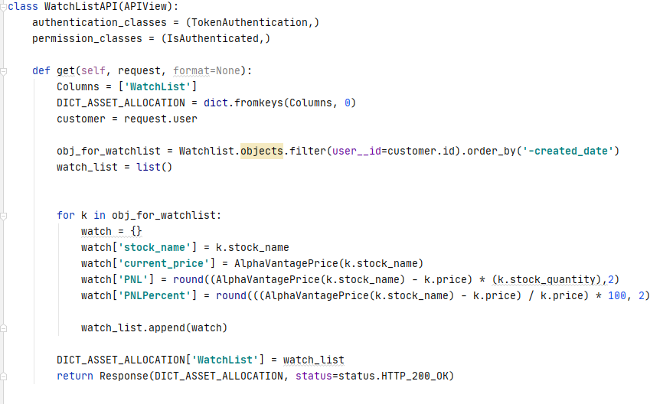

**The Above API is taking the data from the Watchlist Database throwing the data on the front end through Response.**

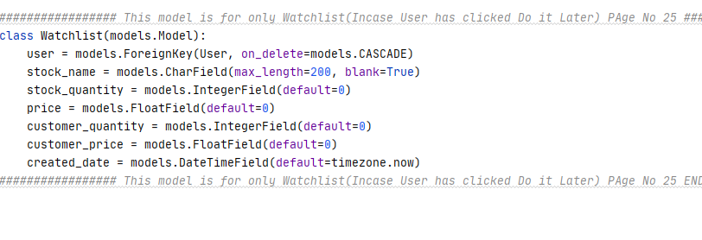

**DONE!!!**